

**Computer Vision and Pattern Recognition**

**Assignment -4**

**Region Growing Image Segmentation Using MATLAB**

Course Teacher: MOHAMMAD EHSANUL KARIM

Submitted by:

|  |  |
| --- | --- |
| Name | ID |
| Rahman, Sajidur | 12-20981-1 |
| Biswas, Ummoy | 12-20886-1 |
| Islam, Tawhid-Al- | 12-21003-1 |
| Rahman Chowdhury Mustafizur | 12-20786-1 |

Region Growing Image Segmentation

Our target was to do a region growing image segmentation. The following steps are followed in our implementation:

i) From the main function we have read an image covert it to gray-scale and applied filtering (multiple times).

ii) We then took a seed value to grow region from the image.

iii) We have implemented region growing on the function “RegionGrowing.m”.

iv) We have used a structure from “regionvalue.m” function to track our region growing sequence.

V) “findRegion.m” function finds the next region to grow.

vi) Our “status” matrix shows the grown region on the image accordingly.

Our variables:

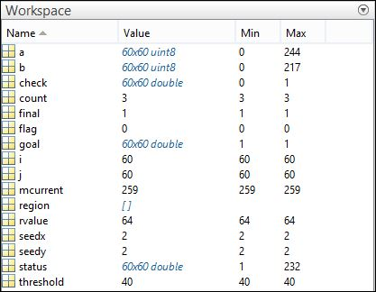

“status” variable shows the region grown from the given image (status matrix):

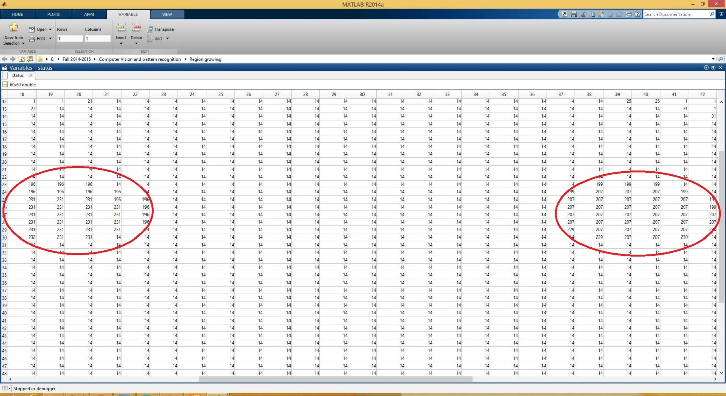

Here, Red marker areas are the two eyes from the tested “test.jpg” image. From the matrix we can see the eyes have a region and their surroundings are the face region of that image.

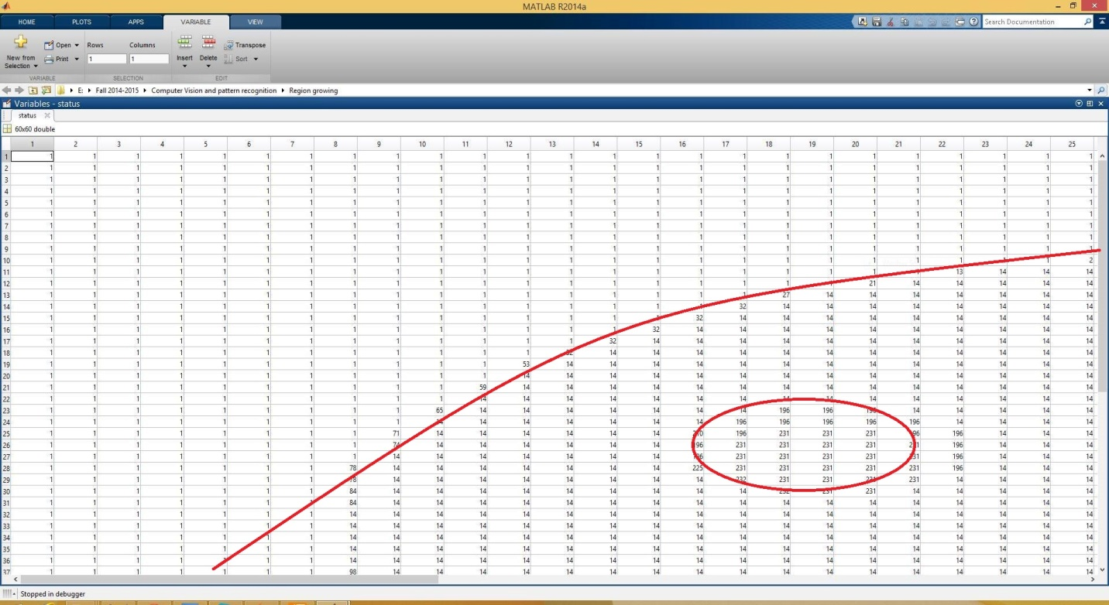

The big line here shows the boundary of the face of the given image on the ‘top-left’. The ‘bottom-right’ shows the face segment of the image.